

Document 522

POST-ASSESSMENT REPORT

CHAPTER: Rensselaer Polytechnic Institute

COUNTRY: Panama

COMMUNITY: Isla Popa II (Sandubidi)

PROJECT: Development of Clean Water Sources

PREPARED BY

Kammi Shah

Kyle Geisler

Ambar Mena

Jesse Freitas

November 17th, 2013

ENGINEERS WITHOUT BORDERS-USA

www.ewb-usa.org

**Post-Assessment Report Part 1 – Administrative Information**

1. **Contact Information**

|  |  |  |  |  |
| --- | --- | --- | --- | --- |
|  | **Name** | **Email** | **Phone** | **Chapter Name**  **or**  **Organization Name** |
| **Project Leads** | Kyle Geisler | Kgeisler52@gmail.com | 845-399-1497 | EWB-RPI |
| **President** | Kathleen DiMilia | kathleendimilia@gmail.com | 845-  707-  1481 | EWB-RPI |
| **Mentor #1** | Alexander Michaels | Alexander.Michaels@arcadis-us.com | 518-  275-  7621 | EWB-RPI |
| **Mentor #2** | David Railsback | David.Railsback@arcadis-us.com | 978-  895-  3220 | EWB-RPI |
| **Faculty Advisor (if applicable)** | Chip Kilduff | kilduff@rpi.edu | 518-  276-  2042 | EWB-RPI |
| **Health and Safety Officer** | Vincenz Buhler | vincenz541@gmail.com | 904-  563-  0917 | EWB-RPI |
| **Assistant Health and Safety Officer** | Kammi Shah | kammishah@gmail.com | 908-  279-  4875 | EWB-RPI |
| **Education Lead** | Jesse Freitas | freitas.jesse@gmail.com | 973-  303-  7536 | EWB-RPI |
| **NGO/Community Contact** | Rajan Patel | Rajan.Patel@ch2m.com |  | EWB-Panama |

1. **Travel History**

|  |  |  |
| --- | --- | --- |
| **Dates of Travel** | **Assessment or Implementation** | **Description of Trip** |
| Jan. 7-12, 2012 | Assessment 1 | First trip to assess project feasibility, community’s main problems, and create a relationship with the community members. |
| Aug. 12-21, 2012 | Assessment 2 | Second trip to collect additional data, forge partnerships with local organizations, and sign a contract with the community of Isla Popa II. |
| Aug. 12-17, 2013 | Assessment 3 | This third trip to collect water data from community water sources, survey the community on water needs and take measurements of pavilion for pilot project. |

1. **Travel Team**

|  |  |  |  |  |
| --- | --- | --- | --- | --- |
| **Name** | **E-mail** | **Phone** | **Chapter** | **Student or Professional** |
| Kyle Geisler | kgeisler52@gmail. com | 845-399-1497 | EWB-RPI | Student |
| Vincenz Buhler | vincenz541@gmail.com | 904-563-0197 | EWB-RPI | Student |
| Kammi Shah | kammishah@gmail.com | 908-279-4875 | EWB-RPI | Student |
| Jesse Freitas | freitas.jesse@gmail.com | 973-303-7536 | EWB-RPI | Student |
| Ambar Mena | menaa2@rpi.edu | 857-919-5829 | EWB-RPI | Student |
| Alexander Michaels | Alexander.Michaels@arcadis-us.com | 518-275-7621 | EWB-RPI | Professional |

1. **Health and Safety**
   1. **Incident Reports**

**Did any health or safety incidents occur during this trip? ___Yes _X_No**

**If there were any health and safety incidents during the trip, check “Yes” and submit your completed 612 - Incident Report document as a separate attachment with this report. For further details, refer to this section in the 531 – Post-Assessment Trip Instructions. If there were no incidents, check “No.”**

1. **Monitoring - Current Status of all Past-Implemented Projects in Program**

|  |  |  |  |  |  |  |  |
| --- | --- | --- | --- | --- | --- | --- | --- |
| **Project Type** | **Project Discipline(s)** | **Date of Completion**  **(m/d/y)** | **Functionality**  **(enter one range**  **per project)\*** | | | **Periodic Maintenance\***  **(yes or no)** | **Demonstration of Knowledge Transfer\***  **(yes or no)** |
| 0-50% | 50-75% | 75-100% |
| N/A | N/A | N/A | N/A | | | N/A | N/A |

**\*Please read accompanying instructions for information on how to complete these columns.**

1. **Budget** 
   1. **Project Budget**

**Project ID: 8801**

**Type of Trip: A**

|  |  |  |  |  |  |
| --- | --- | --- | --- | --- | --- |
| **Trip type:** **A**= Assessment; **I**= Implementation; **M**=Monitoring & Evaluation | | | | |  |
| **Trip Expense Category** | **Estimated Expenses**  ***(Fill in from Pre-trip Report)*** |  | **Actual Expenses** |
| ***Direct Costs*** |  |  |  |
| **Travel** |  |  |  |
| Airfare | 3500.00 |  | 6,559.98 |
| Gas |  |  | 55.04 |
| Rental Vehicle |  |  |  |
| Taxis/Drivers | 1000 |  | 320.00 |
| Misc. |  |  |  |
| ***Travel Sub-Total*** | $3,600 |  | $6,935.02 |
| **Travel Logistics** |  |  |  |
| Exit Fees/ Visas |  |  |  |
| Inoculations |  |  |  |
| Insurance |  |  |  |
| Licenses & Fees |  |  |  |
| Medical Exams |  |  |  |
| Passport Issuance |  |  |  |
| Misc. |  |  | 86.52 |
| ***Travel Logistics Sub-Total*** | $0 |  | $86.52 |
| **Food & Lodging** |  |  |  |
| Lodging |  |  | 85.50 |
| Food & Beverage (Non-alcoholic) | 460 |  | 334.51 |
| Misc. |  |  |  |
| ***Food & Lodging Sub-Total*** | $460 |  | $419.71 |
| **Labor** |  |  |  |
| In-Country logistical support |  |  |  |
| Local Skilled labor |  |  |  |
| Misc. |  |  |  |
| ***Labor Sub-Total*** | $0 |  | $0 |
| **EWB-USA** |  |  |  |
| Program QA/QC | $1,500.00 |  | $0 |
| ***EWB-USA Sub-Total*** | $1,500.00 |  | $0 |
| **Project Materials & Equipment (Major Category Summary*)*** |  |  |  |
|  |  |  |  |
| Incubator | 3797.00 |  | 3797.00 |
| Sample Rack |  |
| Thermometer and Whirlpak bags |  |
| Filter and vacuum assembly |  |
| DR/850 Calorimeter | 1041.00 |  | 1041.00 |
| Arsenic Low Range Test Kit | 152.00 |  | 152.00 |
| 3, 12V Backup Batteries | 150.00 |  | 150.00 |
| Prototyping at RPI | 160.00 |  | 160.00 |
| Contractor Expenses | 200.00 |  | 200.00 |
| Misc. Materials |  |  | 298.21 |
| ICP Metals Water for Arsenic Testing |  |  | 390.00 |
| ***Project Materials & Equipment Sub-Total*** | $5,500.00 |  | $6,188.21 |
| **Misc. *(Major Category Summary)*** |  |  |  |
| Report Preparation |  |  |  |
| Advertising & Marketing |  |  |  |
| Postage & Delivery |  |  |  |
| Misc. Other |  |  |  |
| ***Misc. Sub-Total*** | $0 |  | $0 |
| **TOTAL** | $11,060.00 |  | $6,188.21 |
|  |  |  |  |
| **EWB-USA National office use:** |  |  |  |
| ***Indirect Costs*** |  |  |  |
| **EWB-USA** |  |  |  |
| Program Infrastructure | $0 |  | $0 |
| ***EWB-USA Sub-Total*** | $0 |  | $0 |
| ***TRIP GRAND TOTAL (Does not include Non-Budget Items)*** | $0 |  | $0 |
|  |  |  |  |
| **Non-Budget Items:** |  |  |  |
| ***Additional Contributions to Project Costs*** |  |  |  |
| **Community** |  |  |  |
| Labor |  |  |  |
| Materials |  |  |  |
| Logistics |  |  |  |
| Cash |  |  |  |
| Other |  |  |  |
| ***Community Sub-Total*** | $0 |  | $0 |
| **EWB-USA Professional Service In-Kind** |  |  |  |
| Professional Service Hours |  |  |  |
| Hours converted to $ *(1 hour = $100)* | $0 |  | $0 |
| ***Professional Service In-Kind Sub-Total*** | $0 |  | $0 |
| ***TRIP GRAND TOTAL (Includes Non-Budget Items)*** | $0 |  | $0 |
|  |  |  |  |
| **Chapter Revenue** |  |  |  |
| ***Funds Raised for Project by Source*** | **Raised Before Trip** |  | **Actual Raised by end of Trip** |
| **Source and Amount *(Expand as Needed)*** |  |  |  |
| Engineering Societies |  |  |  |
| Corporations |  |  |  |
| University | 10,000.00 |  |  |
| Rotary |  |  |  |
| Grants - Government |  |  |  |
| Grants - Foundation/Trusts |  |  |  |
| Grants - EWB-USA program | 18,500.00 |  |  |
| Other Nonprofits |  |  |  |
| Individuals | 1,403.54 |  |  |
| Special Events | 1,812.00 |  |  |
| Misc. |  |  |  |
| EWB-USA Program QA/QC Discount Amount |  |  |  |
| EWB-USA Program Infrastructure Discount Amount |  |  |  |
| ***Total*** | $0 |  | $0 |

* 1. **Professional Mentor/Technical Lead Hours**

|  |  |  |  |  |
| --- | --- | --- | --- | --- |
| **Name(s) of Professional Mentor(s) (student chapters) Technical Lead(s) (professional chapters)** | **Pre-trip hours** | **During trip hours** | **Post-trip hours** | **Total Hours** |
| **1.** |  |  |  |  |

1. **Project Discipline(s): Check the specific project discipline(s) addressed in this report. Check all that apply.**

**Water Supply**

____ Source Development

_X_ Water Storage

_X_ Water Distribution

_X_ Water Treatment

____ Water Pump

**Sanitation**

____ Latrine

____ Gray Water System

____ Black Water System

**Structures**

____ Bridge

____ Building

**Civil Works**

____ Roads

____ Drainage

____ Dams

**Energy**

____ Fuel

____ Electricity

**Agriculture**

____ Irrigation Pump

____ Irrigation Line

____ Water Storage

____ Soil Improvement

____ Fish Farm

____ Crop Processing Equipment

**Information Systems**

____ Computer Service

1. **Project Location**

**Latitude:** -82.11667

**Longitude:** 9.183333

**Post Assessment Report Part 2 – Technical Information**

1. **EXECUTIVE SUMMARY**

This document outlines a detailed description of the accomplishments and endeavors of Engineers Without Borders (EWB) at Rensselaer Polytechnic Institute (RPI) during the third assessment trip to Sandubidi in August of 2013. Since November 2010, the student chapter of EWB-RPI in Troy, New York has worked with the community of Sandubidi (Popa II) on Isla Popa in the Bocas del Toro region of The Republic of Panama. The project is named “Development of a Clean Water Source” and this is the first project for EWB-RPI.

The project seeks to help implement a system i different stages, the goal is to collect and store adequate volumes of clean water for the community of approximately 300 people. Water must be available for drinking, and should also be sufficient for washing. Community members avoid drinking from the groundwater whenever possible, but are limited by the amount of rain they receive during the dry season between the months of February to April and September to October. On our past visits to the community, we have observed existing rainwater catchment systems that several community members have installed in their own houses. However, in order for these systems to work at their full capacities, several improvements need to be made. This works for our advantage since the community already has an idea of what a rainwater catchment system is, the benefits that it gives to the community and how they function.

Students and professional mentors have conducted assessment trips in January and August of 2012, building a working relationship with the newly founded community water board, other leaders, and in-country partners as well as assessing potential solutions to address the critical concerns for water supply and quality. The most recent trip, conducted August 12th -17th, 2013 was the third assessment trip and included a variety of tasks. These tasks included water testing, community surveying and making measurements of the community pavilion. Based on information we have gathered and analyzed, the chapter has proposed to construct a centralized rainwater catchment system which will be built on the community pavilion. The pavilion water catchment system will be designed to supply the communities youth with a sufficient supply of water. The most recent trip, conducted August 12th -17th, 2013 was the third assessment trip and included a variety of tasks.

During this trip, the travel team collected necessary data to move forward with the design and construction of this system. The trip allowed EWB-RPI to acquire valuable structural data to support the design and implementation of a preliminary system and served to support relations with Isla Popa II. During the trip, the group worked with the community to establish a financial plan, and find out the availability and cost of construction materials. Other important data to the design of our preliminary solution includes the testing of rainwater, tank and well samples, and also the collection of more census information and water use habits**.**

1. **INTRODUCTION**

Isla Popa II is a Panamanian community in need of improved access to clean water. Most of the community’s 350 inhabitants drink, cook, and clean with water acquired from their own or communal rainwater catchment systems. However, during dry seasons, they are forced to acquire their water from contaminated sources. The assessment trip in August of 2013 detailed herein advanced the knowledge of material availability, community financial contributions, and technical and structural information on the community buildings. Additionally, EWB-RPI further engaged the community in the design specifications in order to promote sustainable engineering practices. Lastly, the assessment trip served to provide EWB-RPI with the information necessary to finalize the proposed preliminary design, as well as an agreement with the community about their role in funding and maintenance operations.

1. **PROGRAM BACKGROUND**

The community of Sandubidi does not have reliable access to clean water. During the first assessment trip, it was established that the community runs out of water during the dry seasons (February to April and September to October), resulting in numerous community members drinking unsanitary water from shallow, uncovered wells. During the rainy seasons (May to August and November to January), water gathered by the existing rain catchment systems is not gathered efficiently and in addition, some tanks are contaminated. Laboratory testing conducted by the University of Panama supports our finding that rainwater is a safer water source than the wells that the community currently uses.

Although most families have rain catchment systems, many are not adequately sized.  If the family does not have a catchment system, they either use makeshift barrels to catch rainwater, they often use communal sources such as the one located in the school, the church and/or the visitor’s hut. However, when these resources were depleted, they were forced to use water from one of the many contaminated wells throughout the community. Many such wells are shallow holes dug in the ground, which are exposed at the surface and are not protected from surface runoff and contamination by animals.

Before EWB-RPI arrived to Isla Popa II, however, the community had limited outside resources that could help them improve the water conditions of the people living there. Katie Douglass, a Peace Corp volunteer was their only connection to these means that they so urgently needed. Katie contacted EWB-USA….

1. **PROJECT DESCRIPTION**

Most of the community’s 300 member drink, cook, and clean with water acquired from existing rainwater catchment systems. However, families that do not have a catchment system drink from contaminated wells or publicly available storage tanks located at the community’s school and/or church. The problem with these public storage tanks is that they are not cleaned on a regular basis, allowing the growth of bacteria in the water. Even though during the rainy season water is abundant; there is insufficient storage to provide sufficient water for community members through the dry season. Improvements can also be made to the design of the tank stands as they have posed a safety hazard to the community. Most of the existing tank stands have not been designed or constructed properly to bear the weight of a full water tank. During this past assessment trip we were also able to take measurements of the community pavilion which is the primary location for this pilot project. The chapter is working with the community to develop the best solution to these problems, while taking into account available materials, their financial contribution and most importantly their needs. The current design proposal is to first construct a preliminary system on the public pavilion and possibly one or two more public buildings. Then use these preliminary systems as a baseline to refine the construction process and gathering of materials. Hopefully this will lead to streamlining of the final stage of implementation, community wide construction. For the more ambitious community members this first set of catchment systems will be a great visual aid to accompany construction documents, if they choose to begin construction before EWB-RPI arrives to assist. EWB-RPI will then be able to review the pre-constructed systems and provide recommendations.

1. **TRIP DESCRIPTION**

EWB RPI’s travel team departed on their third assessment trip on Monday, August 12th to spend seven days gathering data needed to finalize the design and implementation plan for a pilot rainwater catchment system. It was also our goal during this trip was to establish a financial sustainability plan with the community, and to survey the community about their individual water demand. Several complications arose during travel from Albany, NY to Panama City, Panama resulting in the team foregoing staying in a hostel Monday night. Instead the team spent a few hours recouping in a market nearby the domestic airport that would bring the team to Isla Colon on Tuesday at 7:30 AM. Once on Isla Colon the team divided in two to purchase groceries and take inventory of a local hardware store. Mid-afternoon on Tuesday the travel team arrived on Isla Popa. Over the next five days all travelers worked to gather extensive dimensional data regarding the community’s pavilion and test water sources throughout the community for bacteria and other contaminants. To test for microorganisms, a Hach Portable Incubator (product number 2569900) and associated testing materials were brought to Panama to conduct total and fecal coliform plate count tests. Due to the lack of power in Isla Popa, the incubator was stored and powered by the Laguna Azul hotel located about 40 minutes away by boat, on the opposite side of the same island. Relations with the owners of this hotel will be advanced as our project continues.

The team also worked to collect data regarding the community’s water habits and typical consumption, desired uses of water and feedback regarding constructability, material selection and appearance of our proposed design. Unfortunately the community meeting planned for Friday, August 16th was cancelled due to a death in a nearby community. In order to receive the feedback needed to finalize our design, financial contribution from the community, and an operation and maintenance plan, a transcribed copy of topics which would have been covered was given to Felix, a member of the water board already established. He agreed to present these topics and develop a plan for funding and maintaining the system which we hope to build. Before departing for the United States on August 18th, inventory of a second hardware store in Isla Colon was taken along with a short meeting with two members of EWB-Panama to discuss our project’s status and their involvement.

1. **COMMUNITY INFORMATION**
   1. **Description of Community**

Isla Popa II is a community of approximately 300 people living on the northwest side of Isla Popa in the Bocas del Toro archipelago in northwest Panama. Also called by the native name of Sandubidi, the village includes approximately 150 children. Almost all of the community members have connections to Bajillas Azules / Comarca Ngobe Bugle, where the first inhabitants arrived from in the 1950s. The name Sandubidi, meaning “point of the boa,” comes from a tremendous boa constrictor that troubled these first settlers and later mysteriously disappeared. People often travel to Isla Popa in small and medium watercraft from Isla Colon, a 30 to 60 minute boat ride, depending on load, boat size, and weather. All travel within the community is by foot.

Today, the community is comprised of around 35 single-family homes, each hosting 1-10 people. The homes are manually built from the hand-cut Nispero wood that is cut from the surrounding jungle. The community is comprised of five unofficial barrios, or neighborhoods, which branch out from the community’s center. At the heart of the community, on the edge of the island, there are several critical structures: the school with three classrooms and two teachers’ rooms, built by the Ministry of Education; an unused cinderblock shelter, built to be a health clinic; an open-air community meeting pavilion; three latrines; two additional teachers rooms; a hut to lodge visiting tourists; a restaurant and craft store; and a small hut previously used by the former Peace Corps volunteer. With the exception of the hand-crafted wood restaurant and two lodging huts, these community buildings are made of cinderblocks. There are three different kinds of roofs; metal panels, thatched palm, and a fiber material, depending on the builder’s preference.

Electricity and telecommunications are available intermittently in Sandubidi. Because of cell towers on Isla Colon, some of the people in Sandubidi have cell phones and can use them intermittently within a day. There are a few generators that provide electricity to the restaurant and individuals in the community. The restaurant has a generator, and a few homes have generators as well.

Drinking water comes primarily from rainwater catchment systems, which are relatively new to most people. Although not all homes have systems, most have built wooden structures to support their tanks. The support structures are usually off the ground but some sit right on the ground. Some tank owners use cloth, screens, or lid filters, and some have no filter or barrier between the water and the outside air. These tanks range in size from 250750 gallons. The water from the tanks is generally okay to drink and any other water usage but the rainwater is not available all year round. One of the houses also has a well, approximately three meters deep, with a PVC pipe system to pull a PVC bucket out for drinking water. The people use hand-dug wells, called pozos, to bathe, wash clothing or dishes, and even to drink when the rainwater systems run dry. These wells are dug into the ground, often at the lowest elevations. There are as many as 20 wells but probably more that are scattered throughout the community. Testing has indicated that this water is not suitable for drinking and water testing results will determine if that water is suitable for other usage. The one other water source is Ojo de Agua, a stream over four kilometers away through the jungle over varying elevations. Waterborne sickness affects as many as 80 people at any given time. Headaches and bacterial skin infections are also common.

The school offers kindergarten through ninth grade, for approximately 4-four hours each day. Teachers are assigned by the government, often from outside the community, and may travel home on certain weekends. After ninth grade, students must leave the island to continue their education.

Chickens and dogs usually roam freely throughout the community. Many may carry diseases, and the chickens are used for laying eggs or slaughtered for their meat. A few select people have livestock, including a pig, several goats, and several cows.

Community members hold various different, intermittent jobs, earning incomes of $150 to $400 per month, depending primarily of whether they have a local tourism job. Some men leave the island each day to work in the nearby mainland or other islands. Others stay on the island and find their own work or projects to complete. Jobs include fishing, cutting and carrying lumber, owning a small community store, a tailor or dressmaker, and working in nearby resorts and restaurants. Fourteen women of the community have formed a group, called Meri Ngobe, to support tourism in the community. These members rotate the responsibility of working in the restaurant, and sell handmade artisan crafts, such as beaded necklaces and bracelets. These crafts, in addition to the newly painted designs on many homes and buildings, include patterns of diamonds and triangles, which are traditional of the Ngobe people.

The primary religions are Mama Tata (a derivative of Christianity), Jehovah’s Witness, and other evangelical Christian religions.

* 1. **Community and Partnering Organization/NGO Resources and Constraints**

In August 2010, a Peace Corps volunteer, Kate Douglass, began working with the community. While Kate planned on using her Peace Corps funding to supply some water improvement projects, the community reached out to EWB-USA for help in September of 2010. The community does not have strong financial resources, so the project must be cost effective and affordable. Labor and transportation are available, as the local men are experts in woodworking and gathering of local materials, and some even have their own boats. During the last trips, the chapter was given contact information for two local hardware stores as well as a hotel near the community that has offered to aid in shipping and storage of building supplies. Since then, EWB-RPI’s partnering organization, EWB-Panama, has provided the chapter with additional recommendations for purchasing materials in-country. The chapter has also been in contact with another hotel in the area, Hotel Laguna Azul Eco Lodge, which has expressed interest in assisting EWB-RPI with the water project. Both hotels have offered assistance in logistics for materials transportation. In this assessment, the chapter will consider the availability of local materials as well as the transportation method when considering different alternatives.

According to the Peace Corps volunteer, construction is feasible any time other than November, the holiday season for the native people. The rainy seasons are from May to August and November to January; however rain is common year round in the area. This will be accounted for in the construction plan via a contingency plan.

The community had a very good relationship with the Peace Corps. While Kate was the only volunteer in the community until she left this past June, two others have previously been in the community.

The chapter’s current NGO in-country partnership is with EWB-Panama. The chapter has been collaborating with EWB-Panama since the planning for the second assessment trip in August of 2012. This partner has signed an agreement with EWB-RPI to assist the chapter with travel arrangements, connecting with other in-country contacts, mentoring in all technical and social aspects of the project, and to help in any way possible. Being a division of EWB, EWB-Panama has extensive experience in projects similar to EWB-RPI’s project and is well connected throughout Panama. One member of EWB-Panama who will be assisting the travel team on this trip also works for another organization, Footprint Possibilities Inc. With this organization, the EWB-Panama member installs rainwater catchment systems throughout communities in Panama. The chapter will be working with him in the planning of the next trip to have him travel to the community while we are there.

Another partner the chapter has worked with is the Floating Doctors. This group is made up of doctors and other volunteers that serve the Bocas Del Toro region and has been a great asset on the past two trips. The Floating Doctors have offered their views of the community from a health perspective. The group has volunteered to help us however possible including sharing medical data, assisting with materials transportation, and collaborating to educate the community. The main constraint with this organization is that they are very busy. Fortunately, they have been working on establishing a more permanent residence in the community. At this point, the Floating Doctors have been visiting Sandubidi monthly for approximately two years.

* 1. **Community Relations**

The community president is Porfirio and the leader of the Water Board is Hombrosio. The chapter has had separate biweekly phone calls with Porfirio and Hombrosio about developments within the community and within the project proceedings. They have provided opinions regarding how they feel, as well as how the community feels, about specific aspects of the project. Efforts were made to establish a stronger understanding with the community on their responsibilities for the project from this point on. This includes financial contributions, operations, and maintenance. During this trip to Isla Popa II the group was able to get a sense of how important this project is for the community, in the same way the community was able to realize how committed to this project EWB-RPI is. This allowed them to feel more comfortable and voice their concerns with regards to the project. During this trip the group was able to clarify any confusion that community members had about the project itself. When walking around the community for the community surveying, the team was able to show them a copy of the intended Pavilion design, which gave them a chance to ask questions and provide the team travel members with feedback about the design.

The chapter will also be furthering its relationship, as well as the community’s relationship, with EWB-Panama. On the previous assessment trip, two members of EWB-Panama joined the travel group in the community throughout the duration of our stay there. During this trip, the team was able to meet with two members of EWB-Panama and talk to them about our concerns before arriving to Isla Popa II. They were also able to look at the design documents and provide feedback about what they believed were the things we should pay attention to when making measurements, and communicating our ideas to the community members at Isla Popa II. Arrangements are being made to allow one or more members of EWB-Panama to visit Isla Popa when EBP-RPI is helping the community build catchment systems.

* 1. **Community Priorities**

The community’s main priority is to obtain a reliable source of clean drinking water that is available to every member of the community. In order for this project to be a success, it is also important for us to establish a project with a low implementation cost that will allow for multiple installations in the Isla Popa II community. They also reaffirmed their need for cleaner water to be used for drinking, cleaning, but most importantly for cooking. During the community surveying, most of the community members expressed a preference in having the rainwater catchment system near the kitchen. This is where most of the clean water is used and it is a valued convenience. Members have expressed that it is also a top priority that the system either be available to all members, or be individual systems for each house.

The community also wants this water system to be low cost to maintain due to their financial concerns. Even though most of the people have an idea of how to clean their tanks, many of the public tanks (i.e church, school, visitors’ hut, teacher’s hut) do not get cleaned often due to the fact that there is not an appointed person in charge of maintaining these systems. Therefore, coming up with a low cost process for cleaning these tanks is crucial. Additional priorities of the community are to have electricity in the school and better working or additional latrines. The community believes it will bring more opportunities to the students if the building has electricity and would like more sanitary latrines.

1. **DATA COLLECTION AND ANALYSIS**
   1. **Summary of Data**
      1. **Water Testing Results**

**Water samples were collected from a variety of sources. The four samples from tanks were collected and brought to Laguna Azul, a local hotel for bacterial testing. Due to travel, the time samples spent away from the source was approximately an hour and a half which exceeded the recommended time, however Bender Laboratory in Albany said the effects of this on our results are relatively negligible. Results showed our primary focus in treatment will be targeting bacterial growth. Most tanks in the community are exposed at the opening and sit in the sun promoting coliform bacteria growth. If tanks are not cleaned regularly, the tank’s bacteria will grow and become a serious health concern. The following page shows an image of the results from testing total coliform on the teacher’s tank which has not been cleaned in at least a year according to the community. The results from testing show that arsenic is not in the soil as expected and there is reason to believe that previous tests yielded false positives due to environmental factors such as heat and phosphates in the sample. Dissolved Oxygen and Coliform testing showed that bacterial coliforms are alarmingly high in number and treatment will be required to resolve this. Figure 1 shows a test for total coliform bacteria that has a high number of colonies while Figure 2 shows a test with no colonies.**

**Samples were properly preserved and brought back to the United States for testing arsenic content at Adirondack Environmental Lab in the Albany area. The results showed that a negligible amount of arsenic is present in the water meaning there is no longer a need to focus on removing arsenic when considering treatment options. Tests were conducted for arsenic several times over the course of the project. On the first and second assessment trips arsenic was discovered from field testing and attention was brought to the Univeristy of Panama. Professors of the university believe arsenic is unlikely found in the soil in the country and that field tests must have yielded false positives. From the negative results from this trip as well as the results from Adirondack Environmental Services, arsenic should not be in the soil and the past field tests must have given erroneous data. Causes for this error are potentially due to phosphates present in the water causing a low pH and the heat of the environment when testing.**

**Figure 1: Teacher’s Tank Total Coliform Test. Dark red spots are bacterial colonies.**

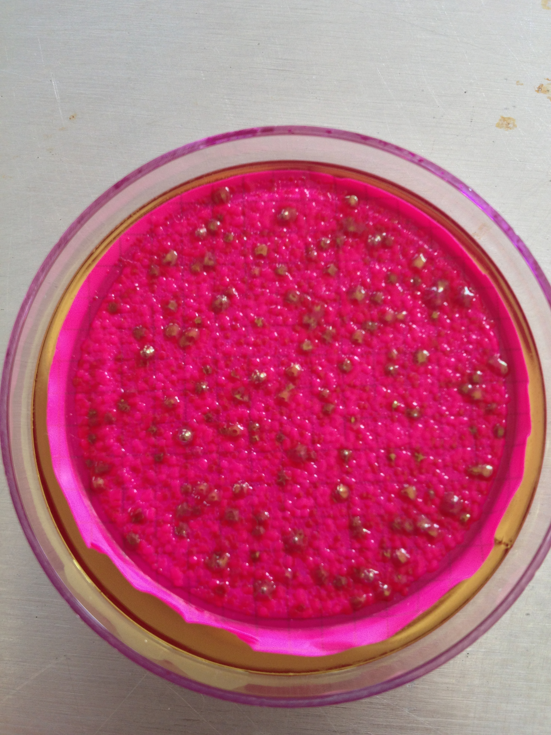

**Figure 2: Fishing Cooperative Tank Coliform Test. There are no colonies in this test.**

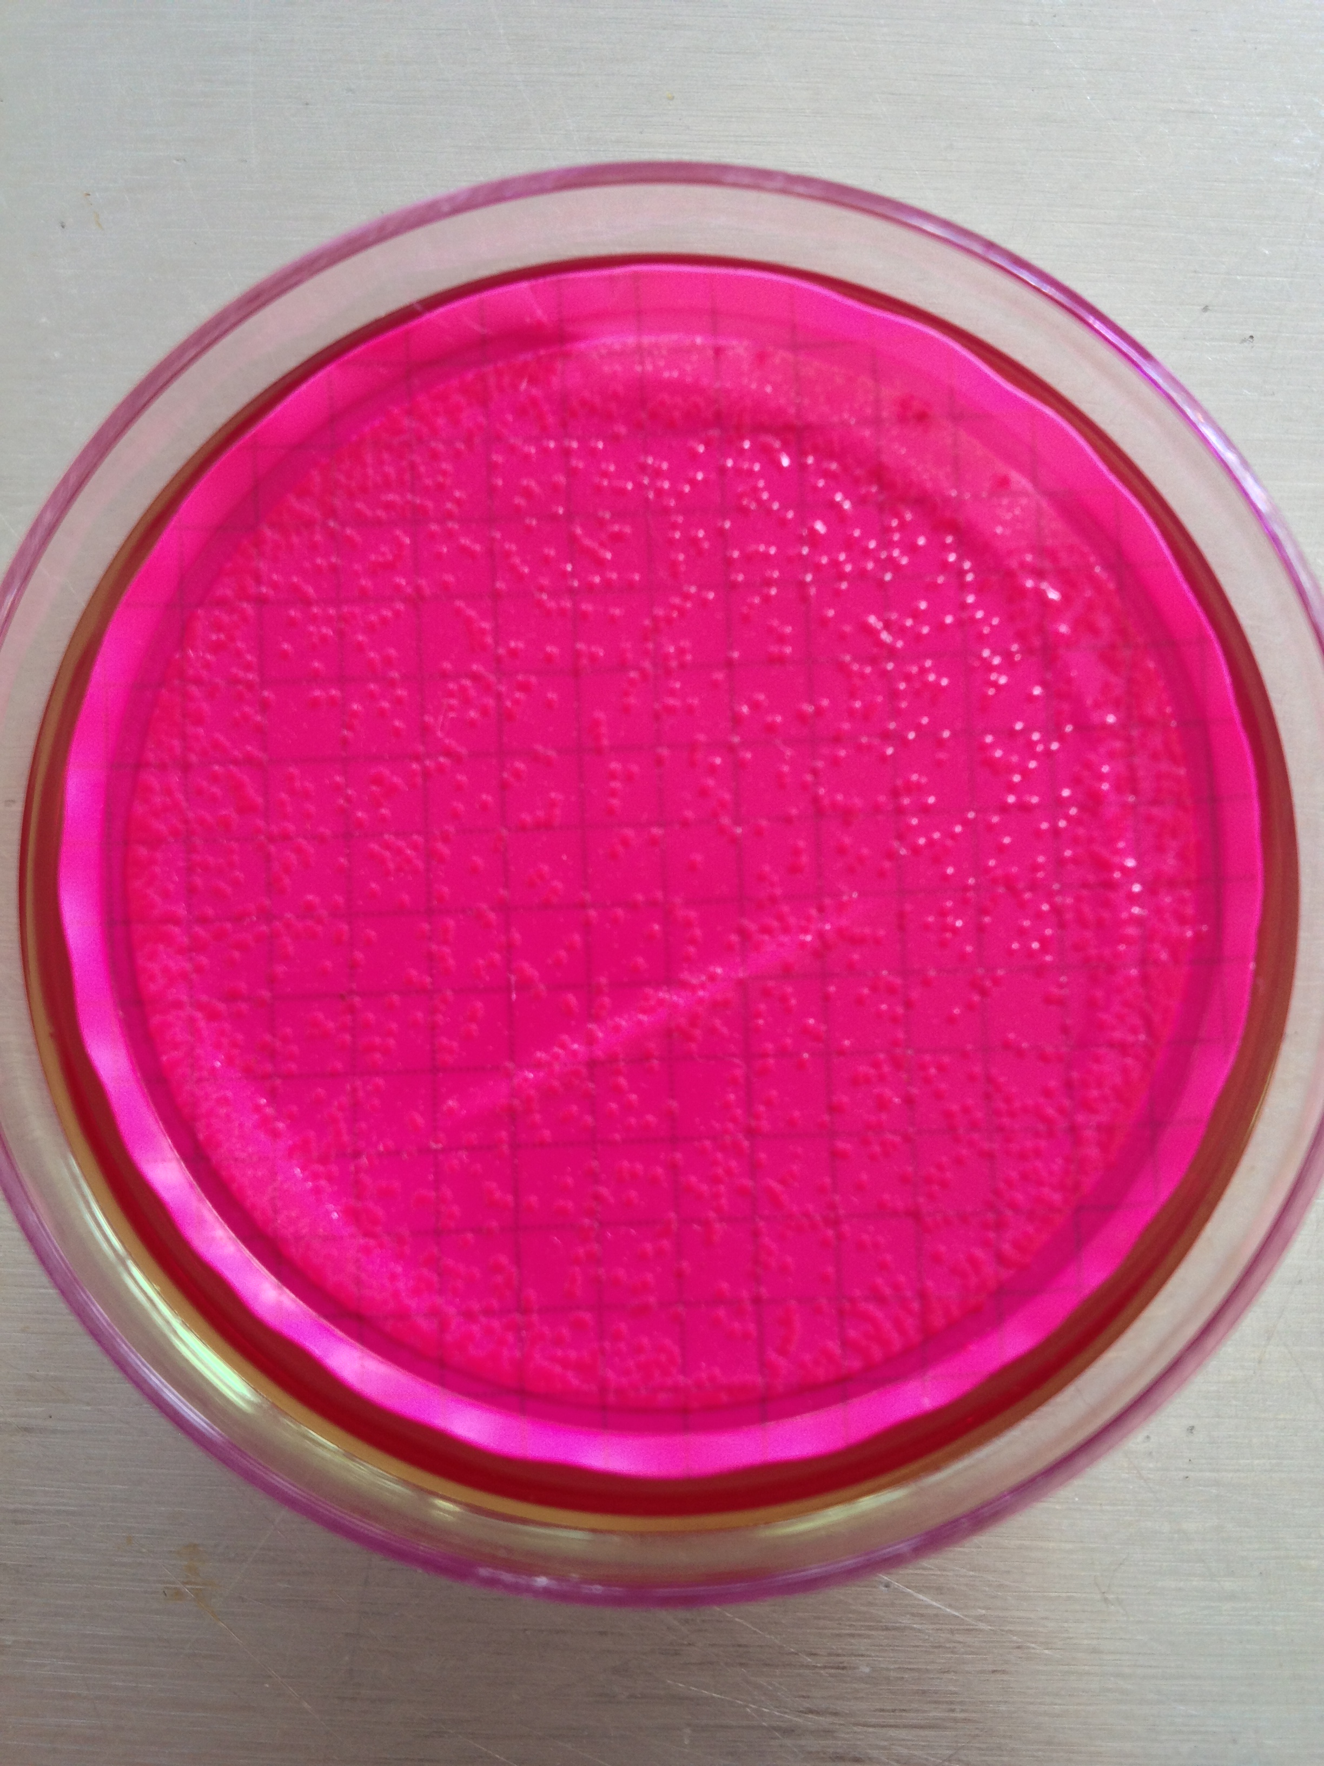

**Table 1: Water Quality Test Results**

|  |  |  |  |  |  |  |  |  |  |
| --- | --- | --- | --- | --- | --- | --- | --- | --- | --- |
| **Sample** | **Location** | **pH** | **Turbidity (JTU)** | **Alkali-nity** | **Arsenic (ppb)** | **Iron (mg/L)** | **Dissolved Oxygen (mg/L)** | **Spec. Cond.** | **TDS (ppm)** |
| **1** | **Fishing Cooperative** | **4.5** | **20** | **20** | **0** | **0.00** | **2.50** | **40** | **27** |
| **2** | **Teacher’s Home** | **4.5** | **0** | **20** | **0** | **0.11** | **6.90** | **30** | **20** |
| **3** | **School Tank** | **5.0** | **10** | **40** | **0** | **0.09** | **8.7** | **30** | **20** |
| **4** | **Church Tank** | **5.0** | **10** | **20** | **0** | **0.19** | **7.8** | **40** | **27** |
| **5** | **Cafeteria Well** | **4.0** | **50** | **20** | **20** | **2.66** | **2.1** | **170** | **114** |
| **6** | **Cement Well** | **5.0** | **10** | **40** | **10** | **6.24** | **4.1** | **80** | **54** |

**Table 2: Coliform Testing results. Coliform Testing Data was collected but due to time constraints, the group was only able to test the four tank samples that were collected.**

|  |  |  |  |
| --- | --- | --- | --- |
| **Sample** | **Location** | **Fecal Coliform** | **Total Coliform** |
| **1** | **Fishing Cooperative** | **0 Colonies** | **0 Colonies** |
| **2** | **Teacher’s Home** | **~60 Colonies** | **~75 Colonies** |
| **3** | **School Tank** | **0 Colonies** | **~40 Colonies** |
| **4** | **Church Tank** | **6 Colonies** | **0 Colonies** |

* + 1. **Tank Structural Analysis**

**During the trip the group collected pictures, measurements, and construction information from a variety of tank stands. The community currently has no standard design or method for building the stands. The stability and safety of each stand is dependent on a homeowner’s building experience. The data compiled will allow the chapter to address the specific design and building concerns that include material strength, design buckling, and calculations about how much the wood bends due to weather changes and use.**

**EWB-RPI collected wood samples from the community for testing. The material was identified as Nispero wood, a readily available building material in the community’s region. No literature was found on this special tree, so basic strength testing of the material will be conducted. The elastic modulus (E) and tensile, compressive, and bending strengths will be measured for the Nispero wood samples under an unsaturated and saturated condition. Wood saturation with water can dramatically alter its strength properties and lead to catastrophic failures of structures if saturation conditions persist. Because Popa II has a tropical climate, the chapter deemed it necessary to test the wood samples under this water-treated condition to design the tank stands within safe tolerances. Taking the calculated strength properties, the chapter will be able to design tank stands that utilized safe loading considering the building material’s strength.**

**The height of the tank stand will be dependent on the height of the house, the water usage/pressure the user desires, and also the accessibility for regular cleaning. Increasing the height of the column supports will decrease the stability of the structure if the column width and foundation are not also adjusted. A buckling analysis of the top platform will be performed to make sure the wood can withstand the weight of a full tank and the weight any additional person during periods of cleaning or maintenance. Considering all of the previously listed conditions, the group is using the data collected on the previous trip to create a design document to standardize the building of tank stands.**

* + 1. **Pavilion Measurements**

**The drawings displayed below are currently being revised to consider new information from the trip and the updated drawings will be included in the chapter’s 525 submittal. The new drawings will include measurements of the pavilion’s concrete slab, roof, ceiling height and rainwater catchment system. These drawings will also be used to model the method for attaching gutters to the roof.**

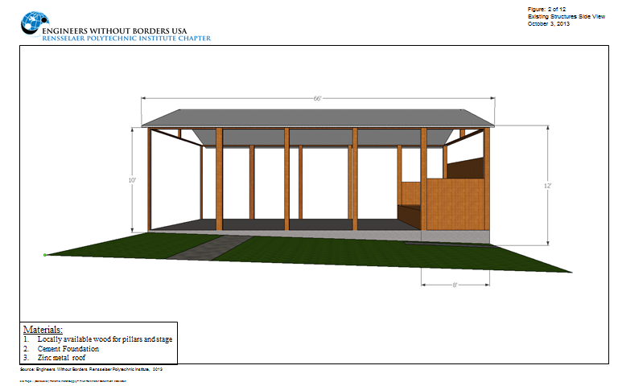

**Figure 1: Existing Structure Side View**

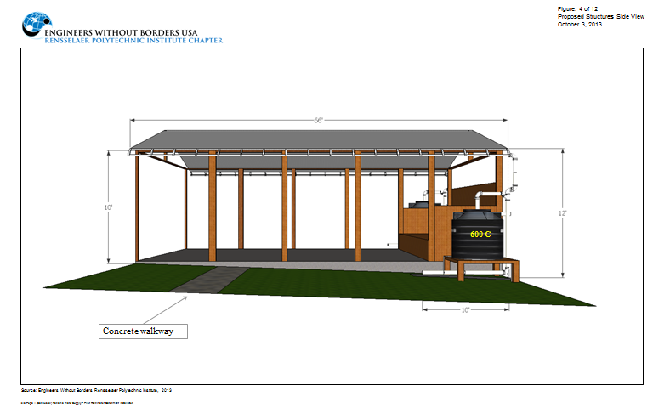

Figure 2: Proposed Structure Side View

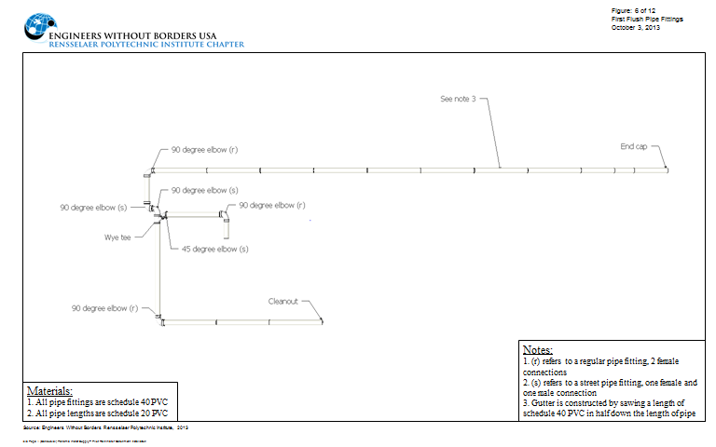

**Figure 3: First First Pipe Fittings**

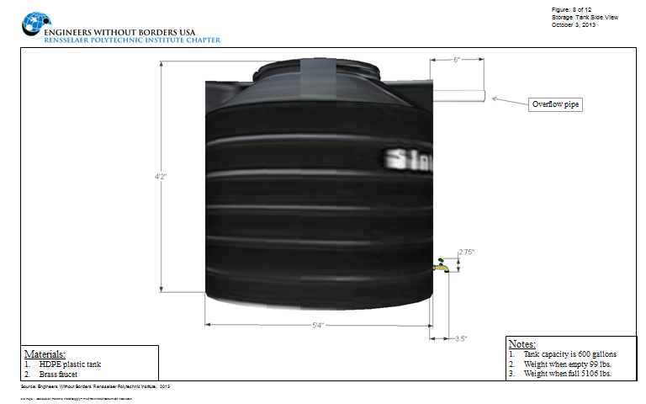

**Figure 4: Water Storage Tank Side View**

* + 1. **Community Water Usage**
  1. **Mapping**

Mapping efforts of the most recent trip were centered on collecting data points for use in creating a drainage plan. A drainage measure will be implemented to carry runoff from the tank, gutters and any spillage that occurs during the withdrawal of water. The objective is to prevent soil erosion beneath the pavilion foundation and tank stand supports while also preventing pooling of water near the tank stand supports which leads to decay and ultimately structural failure of the tank stands.

* 1. **Updated Contacts**

Panama city driver: Jose Pinosa- 6949-3229

1. **MONITORING** 
   1. **Monitoring plan for current project**

EWB-RPI is confident in their ability to monitor the planned project. There are multiple methods of monitoring that the group plans on using. Monitoring will be done primarily by traveling to Isla Popa to check how the implemented system is. Additionally, EWB-RPI will coordinate with NGOs and contacts to ensure project sustainability. The Floating Doctors are an organization based in Bocas del Toro that has met with the travel team on two of the previous trips. EWB-RPI will utilize their medical expertise to monitor the health impacts on the community. In addition, the group plans to continue to call the community at least once every two weeks. These monitoring initiatives will run in parallel to the calls EWB-RPI has with the community. Ultimately, project success will be judged by decreased water borne illness, increased average water supplied per person, and decreased drought periods.

* 1. **Monitoring Plan For Current Project**

|  |  |  |
| --- | --- | --- |
| **Metric** | **Qualitative Measures** | **Quantitative Measures** |
| Water Quality | Use of local water sources compared to bottled water and other sources | Total coliform count, arsenic content, total dissolved solids, and other parameters |
| Community Health | Community opinion of health of individuals | Health data as reported by Floating Doctors and EWB-Panama |
| Water Supply | Community opinion of sufficiency of water supply | Length of the average drought, average quantity of water delivered |

**General Methods for Data Collection:**

*Water Quality*

Total coliform count – a total coliform count will be performed on samples collected by the travel team by an external lab. This procedure achieved useful results on the second assessment trip.

Arsenic content – colorimetric tests will be performed on site as in the first two assessment trips. Required materials include bottles for sampling, reagents, and test strips

Total dissolved solids – an optical test will be performed in the field with a Hach DR/900 colorimeter. The stated detection limit of the colorimeter is 22.1 mg/L. The stated testing method requires blending the sample. Another homogenizing process will likely be used in the trip.

Turbidity - an optical test will be performed in the field with a Hach DR/890 colorimeter. The stated detection limit of the colorimeter is 1 FAU (Formazin Turbidity Unit), which is equivalent to 1 NTU (Nephelometric Turbidity Unit).

Usage – compare the usage of the local water source to bottled water and other drinks by observing the monitoring; the growth plastic trash and refuse, community opinion of water usage, NGO opinion of water usage, and observed water usage.

*Community Health*

Health Data – the Floating Doctors record the services that they provide for the people of Isla Popa II. Cataloging the incidence of kidney and skin related problems will contribute to monitoring overall project effectiveness.

Community Opinion – Consistently surveying the community before, during, and after the implementation process will provide data for the community opinion of their own health.

*Water Supply*

Average Drought – collecting data on the average drought requires the help of the community. Selected community members will monitor record the number of days without water in the tanks.

Average Water Quantity Delivered – community members will monitor water levels before and after rainfalls to understand the quantity of water collected.

Community Opinion - Consistently surveying the community before, during, and after the implementation process will provide data for the community opinion on the adequacy of the water supply.

* 1. **Monitoring Of Past-Implemented Projects**

No other projects have been implemented to-date

1. **COMMUNITY AGREEMENT/CONTRACT**

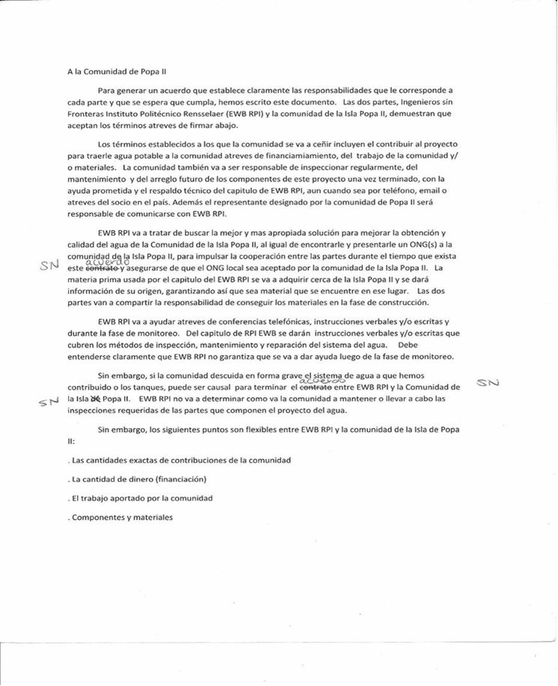

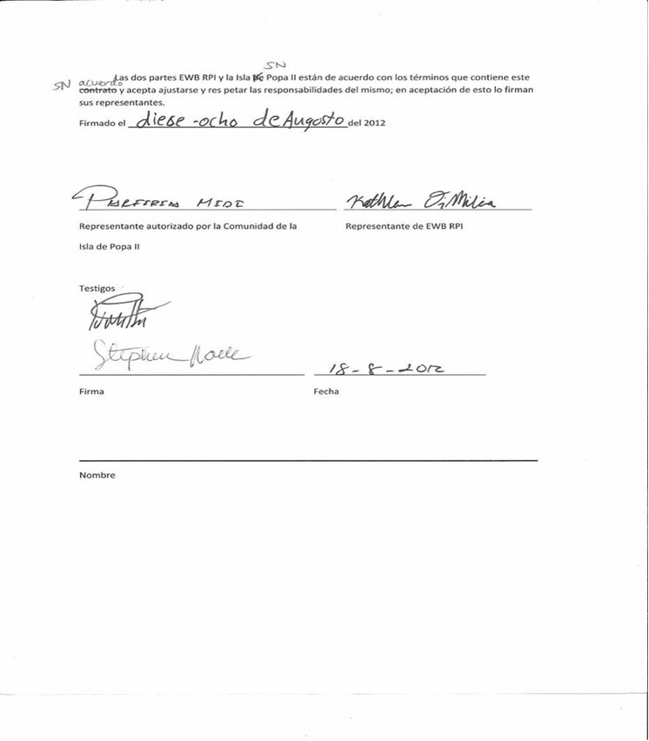

1. **PHOTO DOCUMENTATION**

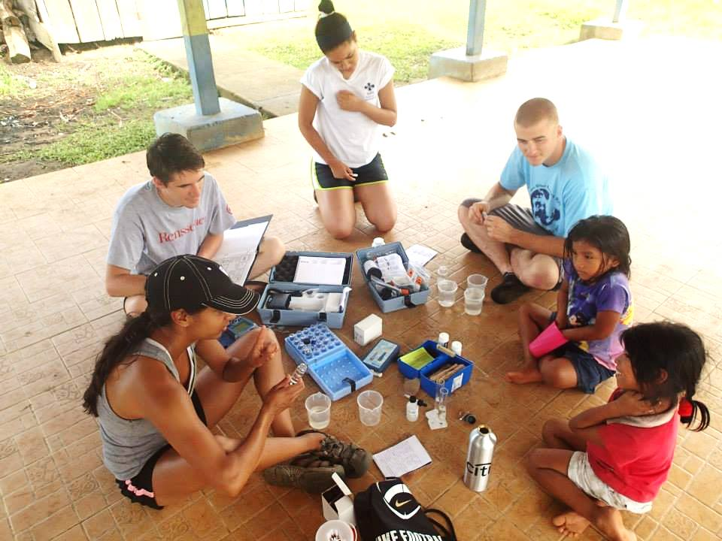

Figure 10.1: The travel team testing for arsenic and various other potential contaminants in the water supply.

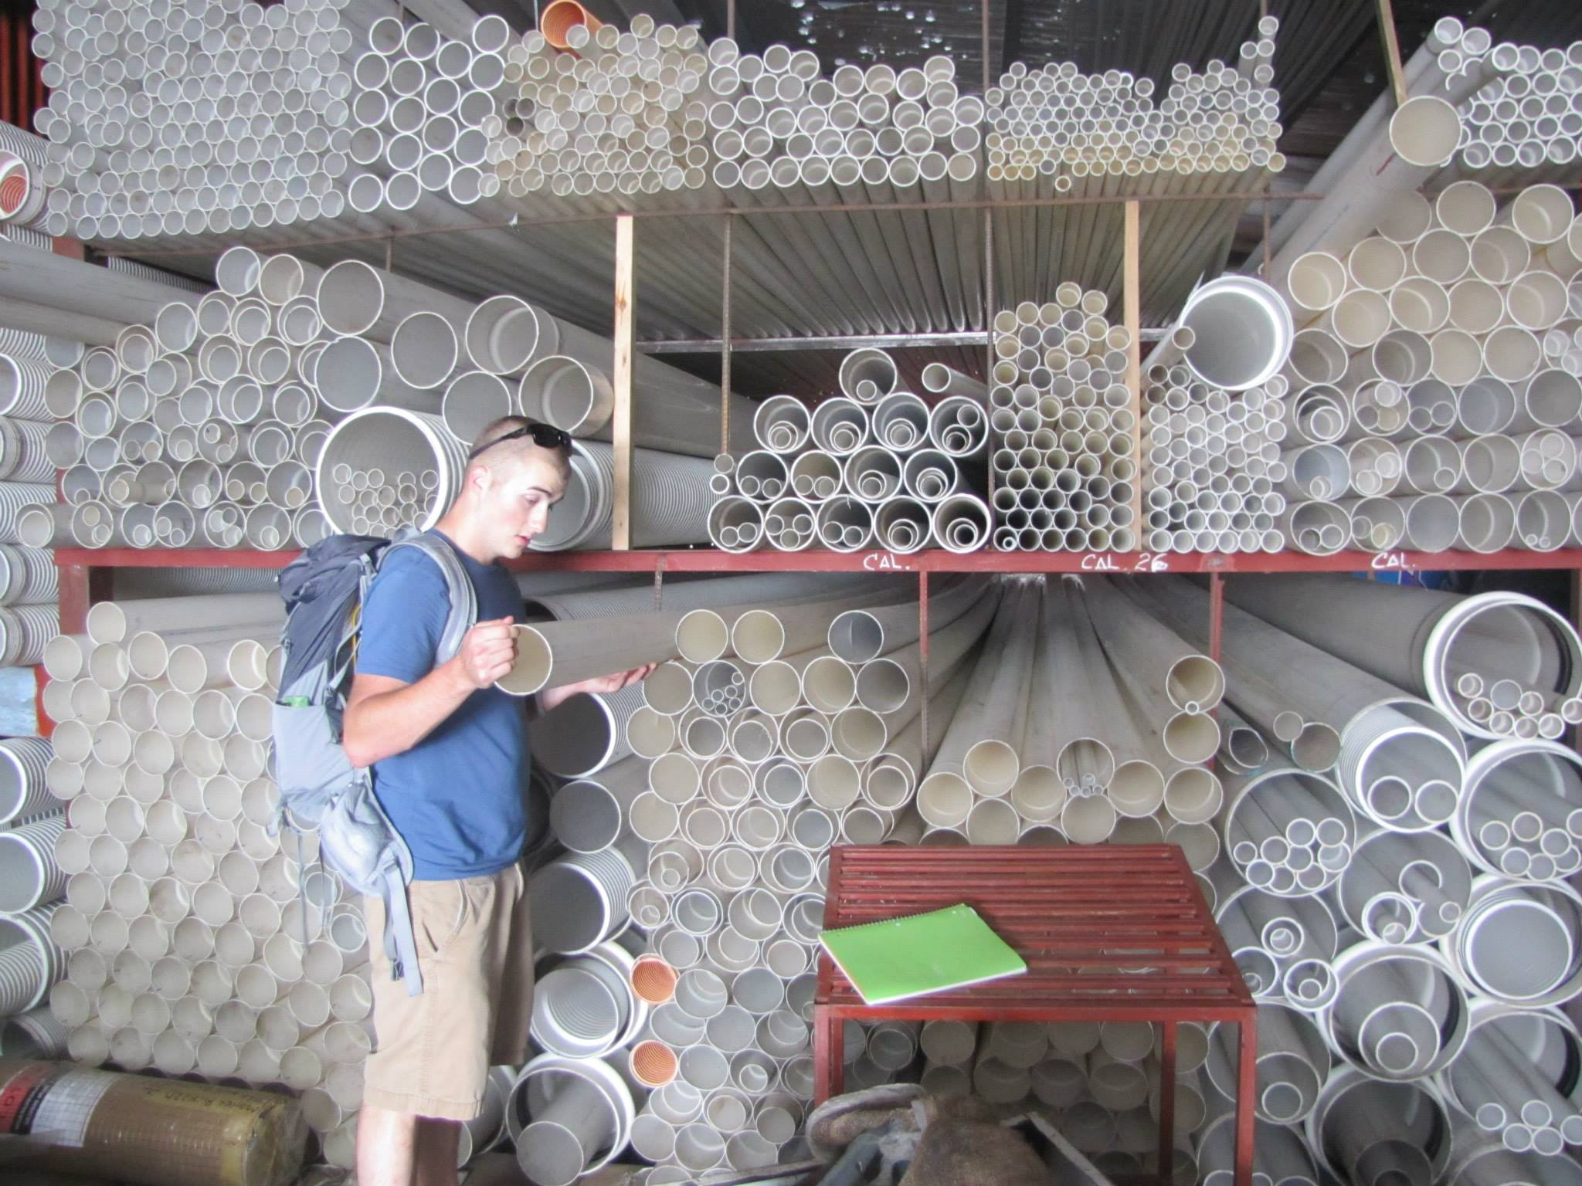

Figure 10.2: The travel team took time on Isla Colon to take inventory of required materials for pilot program at local hardware stores and discuss pricing.



Figure 10.3: The team spent time discussing drawings of a potential design with members of the community and showed bacterial testing results to the community.

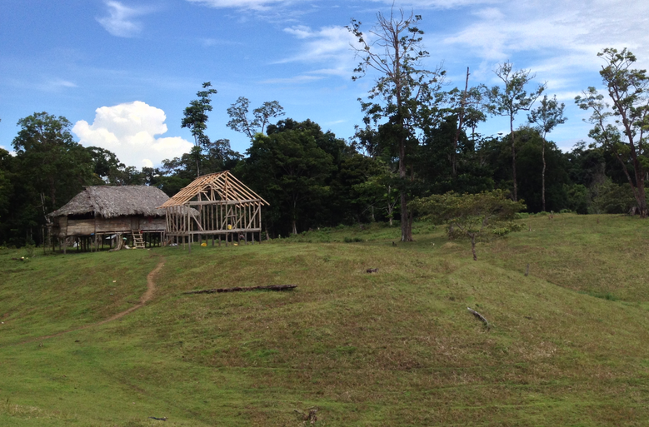

Figure 10.4: Members of the team went to Popa Medio, another area of the community on Isla Popa where we met with community leaders and viewed existing systems

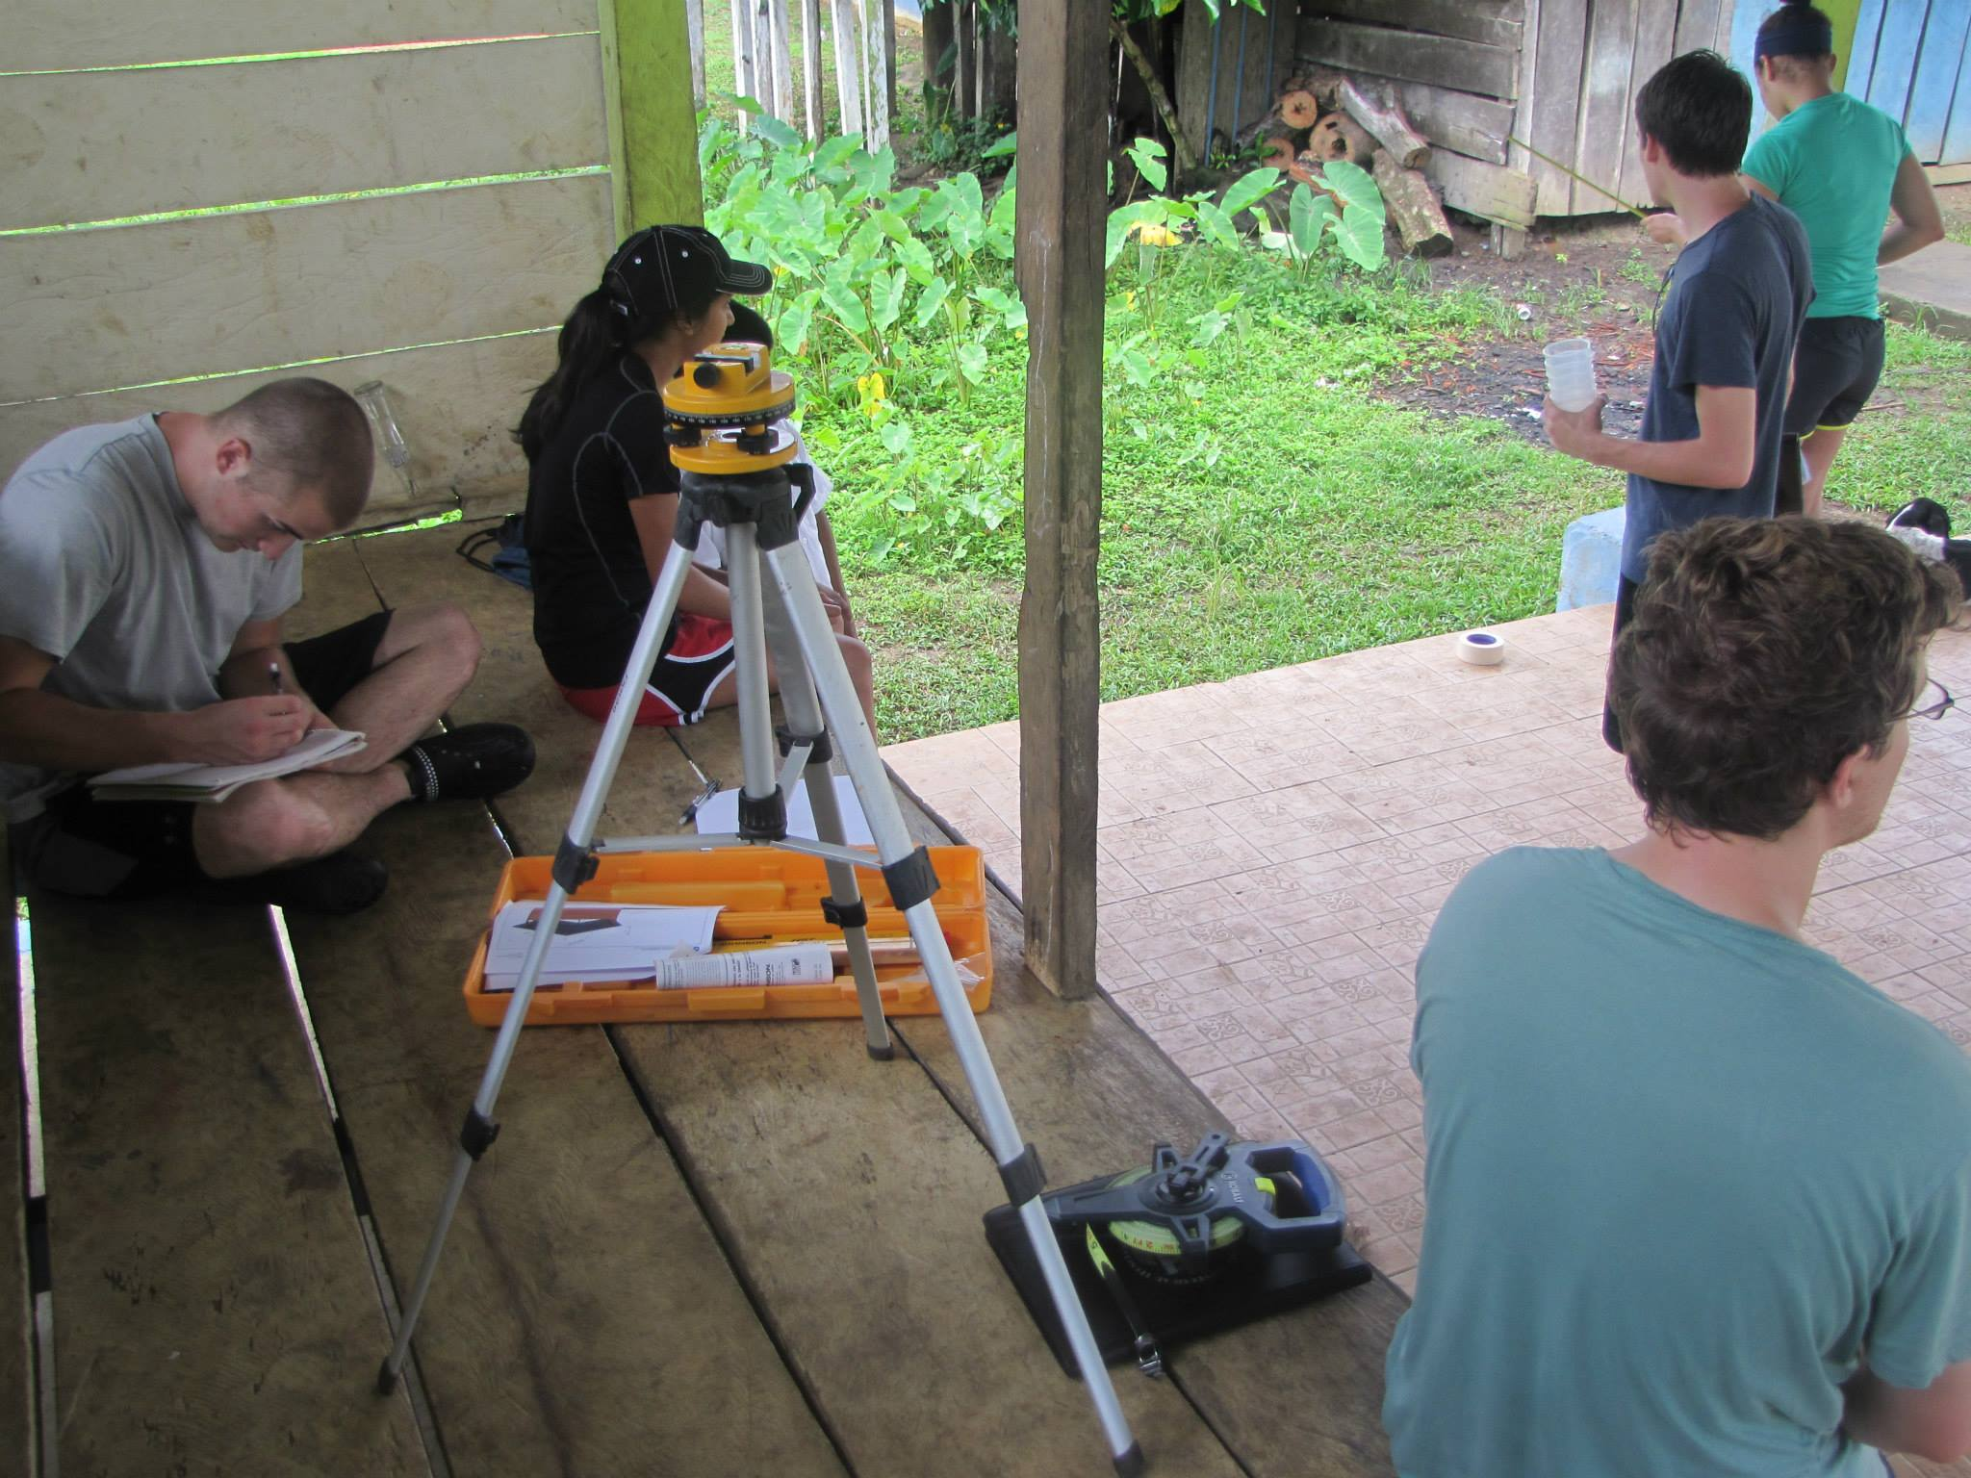

Figure 10.5: The team performing a site survey for the potential pilot system location

1. **PROJECT FEASIBILITY**

The previous project completed by the Peace Corp. volunteer serves as an example of a successful project in Sandubidi. The volunteer proved that the method of finishing a project after community members first provide their own portion of the project, succeeds in this particular community. Given the success of the previous project, the minimal technology required for a sustainable solution, and openness of the community to collaboration, EWB-RPI finds this project to be feasible.

Challenges to the sustainability and feasibility of the project do exist. There have been failed projects by other organizations. Failed attempts by other outsiders can contribute to negativity in the community, but there have also been successful projects by organizations such as Operation Safe Drinking Water. Since returning, the team has had trouble getting an agreement on an operation and maintenance plan with the community. These challenges are a characteristic of many projects in the developing world and the impetus behind EWB-USA’s core values of community ownership and sustainability. Because EWB-RPI has multiple contacts within the community and contacts with partners in the Bocas del Toro region, the team believes that these challenges will be manageable.

1. **LESSONS LEARNED**

|  |  |
| --- | --- |
| Trip Planning | Order all testing equipment months before so that training can be conducted months before |
|  | Itineraries should only have confirmed times that are not subject to change |
|  | Weigh bags before getting to airport |
|  | Spend night before travel with travel team reviewing information |
|  | Call to check flights are still on time morning of |
|  | Each person should have a copy of the itinerary and a Spanish dictionary |
|  | Each person should have a personal goal and task list before travel |
|  | Each task or activity to be performed should have travel team members who will be needed |
|  |  |
| Travel | After multiple flight delays check for reimbursement or reward policy on airline |
|  | Arrange all necessary travel times with water taxi as soon as arriving to coast |
|  | Flight to Isla Colon is about an hour and easier than bus ride |
|  | Booking tickets for In-Country flights should have been done earlier and all by one person |
|  |  |
| Community | Easier to get response from community during surveys when accompanied by another community member |
|  | No community members between the age of 15-25 seen during the day time |
|  | Bring bug repellant burning sticks, can be purchased on island |
|  | Do not eat food that is undercooked |
|  | Community more receptive to our visits each time we come back |
|  | Find out other problems community is having outside the span of our project |
|  | One advantage of the thatch roofs is that they do a better job at ventilating the steam every time it is being cook inside. |
|  | Older generation in community are hesitant to say they will ever use tank water for bathing or washing clothes |
|  | Children will be most excited about your visit to the community |
|  | Community expressed a need for a different solution for the current latrines |
|  | Community members most receptive to meetings when we have prepared documents and pictures for them to view |
|  | Fresh Fruit not the best choice when getting food to bring to island, attracts bugs |
|  | When designating tasks to be performed during that day remember limitations due to weather (heat or rain) |
|  | Bring extra camera batteries |
|  | Candles purchased but not used, attract bugs |

1. **PROJECT STATUS**

According to EWB-USA ratings this project is classified as: Design

The assessment for this project has been completed, the design process is well underway and the team is looking to implement in the near future. Before implementation can begin a design will be finalized along with a plan for operation and maintenance that will be established by the community. The group will also be working to acquire a mentor who has experience in a construction related field to accompany the team during implementation. The necessity to implement a filtration and/or treatment technology will continue to be investigated.

1. **PROFESSIONAL MENTOR/TECHNICAL LEAD ASSESSMENT**
   1. **Professional Mentor/Technical Lead Name (who provided the assessment)**

Alexander Michaels (AM)

* 1. **Professional Mentor/Technical Lead Assessment**

The chapter has completed a third assessment trip in August. The trip was a success, meeting nearly all the goals outlined in the preparation. The group fostered existing relationships, completed valuable water testing, gathered important information from community members, recorded many measurements that will help with system design and communicated the group’s intentions to community members. The travel team overcame many unexpected challenges and remained focused, positive and poised. As a result, lessons were learned that will be priceless for future travelers.

The travel team often split to make progress on different goals. While some members were gathering and testing samples, others were taking measures for the design or completing the survey of community members. This method proved productive, as the team accomplished the trip’s goals on time. The information gathered will be essential to understanding the community’s needs and designing a system that meets these needs.

One important item was not able to be completed due to circumstances out of the group’s hands. A community meeting was planned for the end of the trip to discuss trip results and important sustainability milestones but it had to be cancelled due to an unexpected death in a nearby community. It will be very important for the group to remain in contact with community members to understand their questions and concerns about the project and then discuss what milestones need to be met before implementation can be started.

Before departing, the team also met with two members of EWB-Panama while in Panama City. The meeting was positive and helped keep the relationship between the groups strong. EWB-Panama has been a valuable resource and their support has helped EWB-RPI be successful thus far.

Looking forward, the group has made solid progress but there remains a significant amount of work to be completed in preparation for implementation of the project but with a diligent effort, traveling in January is possible. In the coming weeks and months, the chapter will need to finalize the project design and stay in close contact with the community to ensure required milestones are met. The group is off to a good start, conducting extra meet-ups, delegating work to the large amount of active group members, staying coordinated via email and engaging mentors when needed. With a continued, well-coordinated effort from chapter members and partners, the group will continue to be successful as the project progresses.

* 1. **Professional Mentor/Technical Lead Affirmation**

As a Professional Mentor I acknowledge my involvement in the project and I accept responsibility for the course that the project is taking.